Extra Problems for Thermodynamics

1. A 2.50 x 10-3 m3 sample of gas at 2.30 atm is expanded adiabatically to 5.00 x 10-3 m3. a) Determine the pressure of the gas at this new volume.b) Sketch this process on a PV diagram. c) Demonstrate on your sketch the amount of work done during this expansion. d) Is the work done positive, negative or zero? **a) 0.724 atm b) c) below. d) positive work**

P (atm)

V ( x 10-3 m3)

1

2

3

2.5

5

1. A 1.50 dm3 sample of helium at 130 kPa is expanded isobarically to 4.00 dm3. a) Determine the pressure of the gas at this new volume. b) Sketch this process on a PV diagram. c) Demonstrate on your sketch the amount of work done during this expansion. d) How much work is done by the gas? e) Is the work done positive, negative or zero? **a) 130 kPa (isobaric) b) c) below. d) 325 J e) positive work**

P (kPa)

130

2

1

4

5

V ( dm3)

3

1. On a PV diagram, sketch an isothermal and an adiabatic compression starting from the same initial conditions. a) For which process is the greater amount of work done? b) Is this work positive or negative? **a) The black line is the isotherm because it follows the isothermal lines. The green line is an adiabat because it has a steeper incline than the isotherm. The work done by each is the portion of the blue shaded region from the process line down to the x-axis. b) The adiabatic compression has greater work. c) negative work**

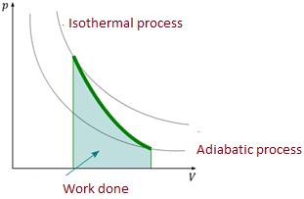

1. 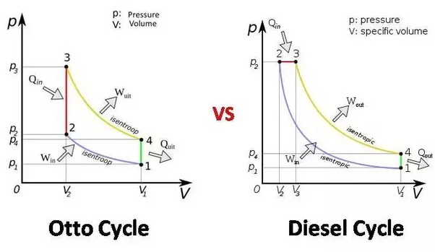An Otto engine is operating on a monatomic gas sample between two temperatures as shown:

Given P1 = 100 kPa, V1 = 0.035 m3, T1 = 300 K, V2 = 0.015 m3, and P3 = 388 kPa.

1. What is the size of the gas sample by this engine in moles? **1.40 mol**
2. Determine the pressure, temperature and volume for all four states involved.

|  |  |  |  |
| --- | --- | --- | --- |
| State | Volume (m3) | Pressure (kPa) | Temperature (K) |
| 1 | 0.035 | 100 | 300 |
| 2 | 0.015 | **233** | **300** |
| 3 | **0.015** | 388 | **500** |
| 4 | **0.035** | **166** | **500** |

1. Determine the heat, work and change in internal energy for the four processes.

|  |  |  |  |
| --- | --- | --- | --- |
| ΔU=Q-W | ΔU (J) | Q (J) | W (J) |
| 1 🡪2 iso T | **0** | **-2960** | **-2960** |
| 2 🡪3 iso V | **3490** | **3490** | **0** |
| 3 🡪4 iso T | **0** | **4930** | **4930** |
| 4 🡪1 iso V | **-3490** | **-3490** | **0** |

1. Determine the amount of heat transferred to the gas during one cycle of the engine. **Qh = 8420 J**
2. Determine the amount of heat released from the gas during one cycle of the engine. **Qc = 6450 J**
3. Determine the amount of work done during one cycle of the engine. **W = 1970 J (two ways to determine, can serve as a check of your work)**
4. Determine the efficiency of this engine. **23.4%**
5. Determine the efficiency of the corresponding Carnot engine operating between the same two temperatures. **40%**
6. 5000 J of heat are added to two moles of an ideal monatomic gas, initially at a temperature of 500 K, while the gas performs 7500 J of work. What is the final temperature of the gas? **T = 400 K**
7. Water near the surface of a tropical ocean has a temperature of 298.2K (250oC), whereas water 700m beneath the surface has a temperature of 280.2K (7.0oC). It has been proposed that the warm water be used as the hot reservoir and the cool water as the cold reservoir of a heat engine. Find the maximum possible efficiency for such an engine. **6.04%**
8. 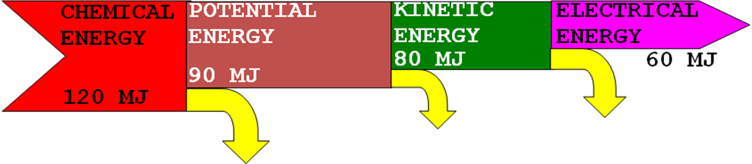Consider the Sankey diagram shown below.
9. What is the efficiency in going from chemical to potential energy? b) What is the efficiency in going from chemical to kinetic energy? c) What is the overall efficiency of the process?

Note: copy didn’t show well: Left arrow is labeled with “chemical energy 120 MJ” and right hand arrow is labeled electrical energy. **a) 75% b) 67% c) 50 %**

1. Suppose a steam locomotive is rated at 5000 horsepower. If its efficiency is 8%, how much wood must be burned in a 2 hour trip? 1 hp = 750 W. Wood has a specific energy of 17.0 MJkg-1. B) For the same problem find out how much coal having a specific energy of 34.0 MJkg-1 must be burned? **a) 1.99 x 104 kg b) 9.93 x 103 kg**
2. A 50.0 MW coal-fired power station is proposed for a city. It is expected to have an efficiency of about 17.5%, and use a coal with a specific energy of 32.5 MJkg-1. A) Calculate the mass of coal that must be burned per day to provide the desired output power. B) How many train cars per day are needed to keep this plant supplied with coal if each car holds 1.5 metric tons of coal? C) If a nuclear power plant powered by uranium-235 has the same output and the same efficiency as the coal-fired plant, how many kg of nuclear fuel will it burn per year? **a) 7.60 x 105 kg b) 506 cars c) 113 kg/ yr**

**Note: 1 metric ton = 1000 kg.** 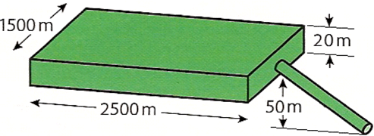

1. A) Calculate the potential energy yield of this hydroelectric scheme. B) If the water flow rate in a hydroelectric power plant is 25 m3 per second, what is the power provided by the moving water? C) If the water is not replenished, how long can this reservoir produce power at this rate?  **a) 490.5 J/kg b) 1.23 x 107 W c) 34.7 days**
2. A wind turbine has a blade length of 12.0 m. Before the air strikes the blades it has a speed of 15.0 ms-1 and a density of 1.20 kg m-3. After passing through the blades, the air has a speed of 5.75 ms-1 and a density of 1.35 kg m-3. The efficiency of the turbine is 18.5%. A) Find the power carried by the air before striking the blades. B) Find the power carried by the air after passing through the blades. C) Find the power output generated by the wind turbine. **a) 9.16 x 105 W b) 5.81 x 104 W c) 1.59 x 105W**
3. A solar heating panel has an efficiency of 40.0%. If the panel is placed in a position where the sun's intensity is *I* = 850. Wm-2over a 6.00-hour period of the day, and is required to raise the temperature of 25.0 kg of water by 10.0° during that time, what must its area be? Recall the *c* = 4186 Jkg-1 K-1. **0.143 m2**
4. The sun radiates energy at a rate of 3.90×1026W. What is the intensity at which energy from the sun reaches Venus if its orbital radius is 108,000,000 km? **2660 W/m2**
5. What is the wavelength of the maximum intensity radiation emitted by a black-body that is at a temperature of 4750 K? **610 nm**
6. In this energy model show that a) the total energy being absorbed by the planet is equal to the total energy being radiated by it b) the total energy being absorbed by the atmospheric greenhouse gases is equal to the total energy being radiated by them and c) the total energy being absorbed by the earth is equal to the total energy being radiated by it.

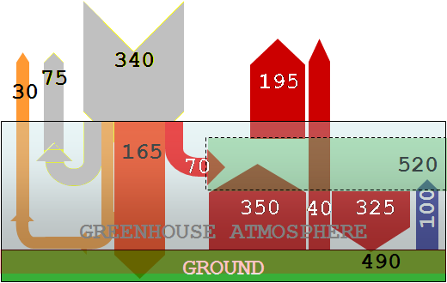

1. **Planet balance**

**340 = 30 +75+195 +40**

1. **Atmosphere balance**

**350 +100 +70= 325 + 195**

1. **Earth balance**

**165 +325 = 350 +40 + 100**